**BPM Questions (20)**

1. What is a Process?
2. The transformation of Input to Output
3. An alignment between costs and effort
4. Another word for “strategy”
5. The difference between technology now and then
6. People in the field of BPM are not very interested in:
7. How can we teach processes to one another?
8. How can we show processes to one another?
9. What is the general approach for business processes?
10. How can we make people follow processes?
11. What is not situated in the level of processes?
12. KPI
13. Organization Goals and measures of organizational sucess
14. Process design and implementation
15. Management of the process
16. What is meant by role design?
17. The question of Why people are leaving a process?
18. Monitoring of failure and success
19. The need of KPI’s
20. Distribution of responsibility: how can tasks and responsibilities can be distributed in a process?
21. What is process science?
22. Interdisciplinary study of processes that is sequence of actions and events which take effect over time and in context
23. Alignment between processes and physics
24. Research and development
25. Building environmentally friendly processes
26. What is the Power of the process?
27. A process is always super easy to handle
28. There is no abstract from to real world to a mini world needed
29. A process is always in the same state, it never changes
30. A process makes an organization fit, increases the effectiveness of an organization and is really innovative
31. What is most important in case of managing a process?
32. To show everything in a process, no detail should be left out
33. Complex management: it is important to cluster, abstract and structure
34. Time management
35. There should be as many main processes as possible
36. What is BPM not about?
37. Modelling
38. Performance Measurement
39. Risk Management
40. Culture
41. BPM should…
42. Be done in every organization, doesn’t matter the business or the size of the organization
43. Just include a few people
44. Never consist any changes
45. deliver Business Value through driving business
46. Which one is not part of the six core capabilities?
47. BPM Governance
48. BPM Finance
49. BPM Culture
50. BPM Technology
51. The BPM Culture includes…
52. Infrastructure
53. Values
54. Skills
55. Roles
56. The BPM Technology includes…
57. Solutions
58. Models
59. Roles
60. Strategy
61. Why is it important to have a context awareness?
62. Because BPM should stick to a general cookbook approach
63. Because BPM should be done just in the sake for doing it
64. Because BPM should fit to the organizational context
65. Context awareness is not relevant at all
66. Which statement is wrong considering a Model?
67. It is a representation
68. It is a reductiveness
69. It is purposefulness
70. It is not an abstraction
71. What are core processes about?
72. How do we get the core processes work?
73. What is needed to give the system the right direction?
74. What value is it delivering for its customer?
75. They are the bottom of the Retail H-Model
76. Which connection is not allowed?
77. A is not allowed:

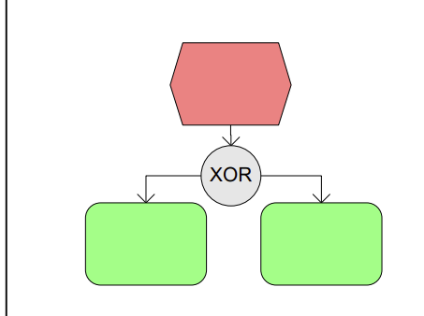

1. 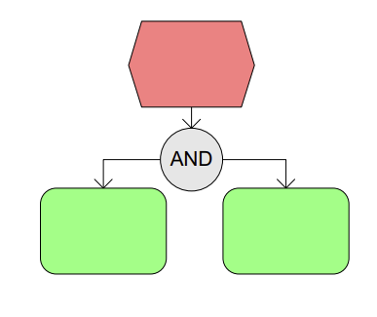

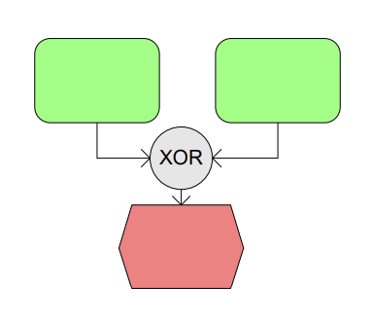

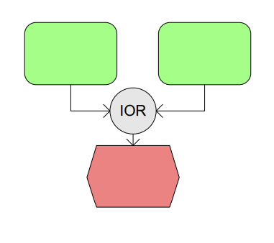

1. Which statement is correct?
2. two events can follow each other
3. XOR: you can go both way A and B
4. There is always a Start and End Function
5. IOR: you can go both way A and B
6. What is important when it comes to digital value creation?
7. It is just about buying an ERP- System
8. It is important to think beyond the technology, what is the interest of the people?
9. It doesn’t matter what other people in the organization think
10. Technology the way it is, is enough
11. Which statement regarding disruptive technology is not correct?
12. We can always improve, but technology gives us a roof
13. Rethink the technology frame
14. Innovation vs. Improvement
15. It is always better to innovate than to improve
16. What is meant by “data is the new oil”?
17. The data itself is useful
18. Everything is always valued
19. Data is just valued if we analyse it, if we look inside
20. There is no need for data at all

**ISM Questions (20)**

1. Which statement is wrong regarding software processes. All software processes should involve
2. Specification – defining what the system should do
3. Design and implementation- defining the organization of the system and implementing the system
4. Roles
5. Validation and Evolution
6. The waterfall model
7. Is an incremental model
8. Belongs to the agile software development
9. is really flexible
10. is simple and easy to explain to customers
11. A project is/does
12. Characterized by the uniqueness of its conditions (objectives, demarcation, organization, resources, etc…)
13. Not require lots of planning and coordination
14. No limited in time by defined start and end dates
15. Riskless
16. Why is project management so special? (which answer is wrong)
17. The product is instangible
18. Software processes are static
19. Many software projects are “one-off” projects
20. Software processes are variable and organization specific
21. What can the project manager do to intervene in case of delays?
22. Just go on without contacting the management
23. Lengthen the critical path
24. Omit features or move to the next release
25. More quality
26. What is meant by risk management?
27. Has nothing to do with danger and the risk of loss
28. Cannot become a real challenge
29. Risk management is always in the same state
30. Identifying risks and drawing up plans to minimize their effect on a project
31. Which statement is not true concerning agile methods?
32. Focus on design
33. Focus on the code
34. Iterative approach to software development
35. Intended to deliver working software quickly and evolve this quickly to meet changing requirements
36. Principles of agile methods. Which statement is true?
37. System requirements won’t change
38. It’s not necessary to keep the maintenance process simple
39. Customer involvement
40. Processes not people
41. What is meant by extrem programming?
42. Extremely fast programming without breaks
43. New versions may be built several times per day
44. Big releases
45. Test- second development
46. What is a benefit of Scrum?
47. Unstable requirements hold up progress
48. Not the whole team has visibility of everything
49. The product is seen in a whole
50. Trust beween customers and developers is established and a positive culture is created in which everyone expects the project to succeed
51. Scaling out and scaling up- Which statement is true?
52. Scaling up is concerned with using agile methods for developing small software systems
53. Scaling out is concerned with how agile methods can be introduced across small organizations
54. Scaling up is concerned with using incremental methods
55. Scaling out introduces agile methods across a large organization
56. Why agile? One statement is false.
57. Customers as vague ideas/ vision at the beginning
58. Systems are less integrated
59. Technology stack is more compley
60. User have much higher expectations regarding the usability of the system
61. Agile…
62. Does replace management
63. Is easy to understand but hard to apply
64. Do not require a certain degree of self- organization
65. Culture is in every organization
66. Non- functional requirments can be… (mark to wrong one):
67. Product requirements
68. Organizational requirements
69. A requirement that specifies a function that a system must be able to perform
70. External requirements
71. How can requirements be elected?
72. There is no need to elect them, since they are clear from the very beginning
73. Interview just one important group of people
74. Talking to various stakeholders
75. Just add requirements what you think is important without asking for other peoples opinion (could be too complex then)
76. User requirements:
77. Are statements in natural language plus diagrams of the services the system provides and its operational constraints
78. Structured document setting out detailed descriptions of the system’s functions, services and operational constraints
79. Defines what should be implemented so may be part of a contract between client and contractor
80. Can just be understood by people with technical background
81. Which statement is wrong regarding system modelling?
82. System modelling is the process of developing abstract models of a system, with each model presenting a different view or perspective of that system
83. System modelling has now come to mean representing a system using some kind of graphical notation which is now almost always based on notations in the UML
84. System modelling helps the analyst to understand the functionality of the system and models are used to communicate with customers
85. System modelling is not really helpful to show the functionality of a system to the customer
86. What is a domain model?
87. A complex class diagrams
88. Describes verbally how all these different terms relate to each other
89. A live dictionary of all terms used in the project
90. Shows specified relationships between the domain classes
91. What is a robustness diagram? (which statement is false)
92. Is basically a simplified UML communication diagram
93. Forces to tie the use case text to the domain objects
94. Fills the gap between the analysis phase (“what”) and the design phase (“how”)
95. Ensures that the use case is not written in the context of the domain models
96. Rules in Robustness Analysis. Which statement is correct?
97. Nouns can talk to other nouns
98. Verbs cannot talk to nouns
99. Verbs can talk to verbs
100. Controllers are nouns

MIS

1. Considering Digital Transformation…
2. The use of technology is not necessary to improve performance of enterprises
3. Digital interaction means developing new digital value chains
4. Digital distribution is an incorporation of digital materiality into physical objects
5. One of the successful themes for economic growth is data, that is often considered as a catalyst for overall economy growth, innovation and digitalization across all economic sectors
6. What is meant by Modularity?
7. How a system is devided into subsystems and how these subsystems interconnect
8. Brings unique content to systems
9. Dynamics
10. No final whole design of digital modules
11. What is the correct order of the stages of Innovation?
12. Development- discovery- diffusion- impact
13. Discovery- development- diffusion- impact
14. Diffusion- discovery- impact – development
15. Discovery- diffusion- development- impact
16. What is a Process Innovation?
17. Significantly new products or services that are embodied in IT or enabled by IT
18. Significantly new way of creating and capturing business value that is embodied in or enabled by IT
19. A new way of doing things in an organizational setting
20. CRM/ERP Systems
21. What is B2B E-Commerce?
22. To describe all types of inter- firm trade to exchange value across organizational boundaries
23. The relationship between customers and organization
24. That portion of B2B commerce that is not enabled by the internet and mobile apps
25. B2B E- Commerce equals B2C E- Commerce
26. What Statement is wrong. Potential Benefits of B2B E-Commerce…
27. Improving quality of products by increasing cooperation among buyers and sellers and reducing quality issus
28. Reduce inventory costs by increasing competition among suppliers
29. Less price transparency
30. Decreases product cycle time by sharing designs and production schedules with suppliers
31. Five Basic Kinds of Organizational Structure. Which statement is not true?
32. Entrepreneurial: small start- up businesses
33. Adhocracy: law firms, school systems, hospitals
34. Machine bureaucracy: midsize manufacturing firm
35. Divisionalized bureaucracy: fortune 500 firms
36. Organization Information Processing Theory. Which statement is wrong?
37. This Theory identifies three important concepts: Information process needs,

Information process capabilities and the fit

1. The organization needs Information to cope with environmental uncertainty and improve their decision making
2. A strategic to cope with uncertainty would be to implement strucutural mechanisms and information processing capability to enhance the information flow and thereby reduce uncertainty
3. An other strategic would be to reduce buffers to reduce the effect of uncertainty
4. What is a ERP System?
5. Integration of business processes in manufacturing and production, finance and accounting, sales and marketing and human resources into a single software system
6. Enterprise Requirement Planning
7. Business Resource Planning
8. ERP is a worldwide acting company
9. What are main factors why ERP- Project might fail? (which answer is wrong)
10. Social commitment
11. Lack of Alignment of ES and BPs
12. Lack of in-House skills
13. The ERP- Project team should consist of just a few people and should not communicate too much with others